**EXPERIMENT NUMBER – 3.9**

**Student Name:** **GIRJANAND TIWARY**  **UID:20BCS4506**

**Branch:** CSE (IOT) **Section/Group:** 20IOT/A

**Semester:** 2nd **Date of Performance:**28/04/2021



AIM OF THE EXPERIMENT – To calculate the velocity of ultrasonic sound through water media.

APPARATUS- Ultrasonic interferometer, sample liquids, high frequency generator etc.

CIRCUIT DIAGRAM-

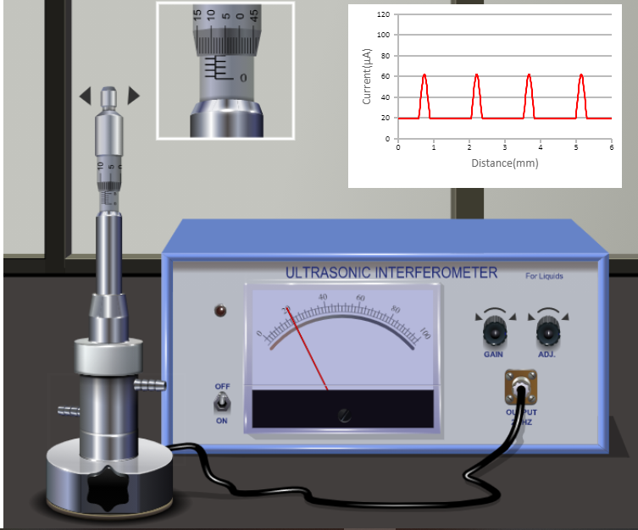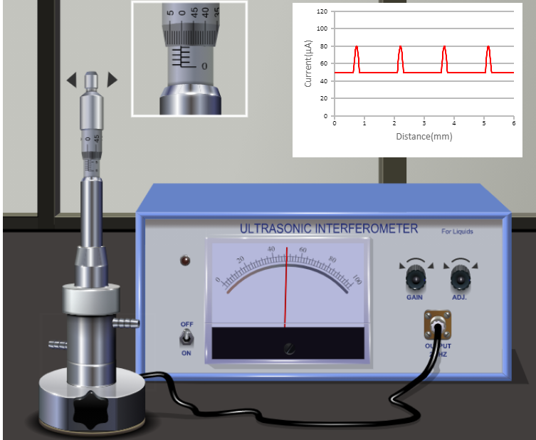

OBSERVATIONS-1.Least count on main scale= 0.5 mm

2.Pitch of circular scale= 0.5

3.Least count of screw gauge= Pitch/no. of divisions on circular scale

= 0.5/50

= 0.01 mm

4.Frequency of the ultrasound used (f) = 2 MHz

5.Medium used= water

Density of water, = 996.458 Kg/m3

|  |  |  |  |
| --- | --- | --- | --- |
| **S.NO** | **Nth ORDER MAXIMA(MM)** | **DIFFERENCE(MM)** | **VELOCITY= ⋋*F-2D(M-/SECOND)** |
| 1. | 0.6 | 0.21 | 1440 |
| 2. | 0.84 | 0.26 | 1560 |
| 3. | 1.1 | 0.26 | 1440 |
| 4. | 1.34 | 0.25 | 1500 |
| 5 | 1.59 | 0.25 | 1500 |
| 6 | 1.84 | 0.248 | 1488 |

**GRAPH (ATTACH IF ANY)-No graph**

**Procedure-**

1. Insert the quartz crystal in the socket at the base and clamp it tightly with the help of a screw provider on one side of the instrument.
2. Unscrew the knurled cap of the cell and lift it away. Fill the middle portion with the experiment liquid and screw the knurled cap tightly.
3. Then connect the high frequency generator with the cell.
4. There are two knobs on the instruments- “Adj” and “Gain” position of the needle on the ammeter is adjusted .The knob “Gain” is used to increase the sensitivity of the instrument.
5. Increase the micrometer setting till the anode current in the ammeter shows a maximum.
6. Note down the micrometer reading.
7. Continue to increase the micrometer setting, nothing the reading at each maximum. Count any number of maxima and call it as n. Subtract the reading at the first maximum from the reading at the last maximum. This will mark the measurement accurate.

**RESULT-** The calculated velocity of the ultrasonic wave through the given liquid medium = 1510 ms-1.

Standard velocity of ultrasonic waves is =1480 m/s

**CONCLUSION -** Ultrasonic sound refers to sound pressure with a frequency greater than the human audible range (20Hz to 20 KHz). When an ultrasonic wave propagates through a medium, the molecules in that medium vibrate over very short distance in a direction parallel to the longitudinal wave. During this vibration, momentum is transferred among molecules.

**LEARNING OUTCOMES**

* It will provide the modest experience that allows students to develop and improve their experimental skills and develop ability to analyze data.
* Ability to demonstrate the practical skill on measurements and instrumentation techniques of some Physics experiments. Students will develop the ability to use appropriate physical concepts to obtain quantitative solutions to problems in physics.
* Students will demonstrate basic experimental skills by setting up laboratory equipment safely and efficiently, plan and carry out experimental procedures, and report verbally and in written language the results of the experiment.
* Students will develop skills by the practice of setting up and conducting an experiment with due regards to minimizing measurement error.

EVALUATION COLUMN (To be filled by concerned faculty only)

|  |  |  |  |
| --- | --- | --- | --- |
| **Sr. No.** | **Parameters** | **Maximum Marks** | **Marks Obtained** |
| 1. | Worksheet completion including writing learning objectives/Outcomes. (To be submitted at the end of the day) | 10 |  |
| 2. | Post Lab Quiz Result. | 5 |  |
| 3. | Student Engagement in Simulation/Demonstration/Performance and Controls/Pre-Lab Questions. | 5 |  |
| 4. | Total Marks | 20 |  |

|  |  |  |
| --- | --- | --- |
| 5. | Teacher’s Signature (with date) |  |